Name: Aavez khan
Roll no: 24CO15
Batch: 01
Class: TE-CO1
GitHub User ID: aavez957
Email: 24co15@aiktc.ac.in
Experiment 10: Open Source Contribution and Mini Project (should be done by students)
GitHub Contribution
Aim
To simulate a basic contribution to an open-source project using Git and GitHub by forking a repository, cloning it locally, creating a branch, making a small documentation change, committing the change, pushing the branch, and creating a Pull Request.
Theory
Open-source contribution allows developers to improve software collaboratively. Git is a distributed version-control system used to track changes in source code, while GitHub provides online repositories and collaboration features such as forks, branches, commits, and Pull Requests. A fork is an independent copy of a repository under a user's account. A clone downloads that repository to the local computer. A branch provides an isolated workspace for making changes without directly changing the main branch. After a change is committed and pushed, a Pull Request (PR) can be created so that the proposed change can be reviewed and merged.

Requirements
• Git installed on the computer.
• A GitHub account.
• Internet connection for GitHub operations.
• A terminal / command prompt.
• A text editor such as VS Code or Notepad.

Step 1: Create Practical Folder
Student Input
mkdir oss_contribution
cd oss_contribution
pwd
Expected Output
/home/student/oss_contribution
Meaning
A separate folder named oss_contribution is created to keep the GitHub practical files organized.

Step 2: Check Git Installation
Student Input
git --version
Expected Output
git version 2.47.0
Meaning
This checks whether Git is installed and available from the terminal. The exact Git version may be different on the computer used for the practical.
Step 3: Configure Git Identity
Student Input
git config --global user.name "Bind Ashish Motilal"
git config --global user.email "24co21@aiktc.ac.in"
git config --global --list
Expected Output
user.name=Aavez khan
user.email=24co15@aiktc.ac.in
Meaning
Git stores the name and email with commits so that the author of a change can be identified.
Step 4: Fork the Repository on GitHub
Student Input
Open the simulated repository:
https://github.com/demo-oss-lab/hello-contribution
Click Fork and create the simulated fork under:
ash3258/hello-contribution-lab
Expected Output
Fork created successfully.
Simulated fork:
https://github.com/ash3258/hello-contribution-lab
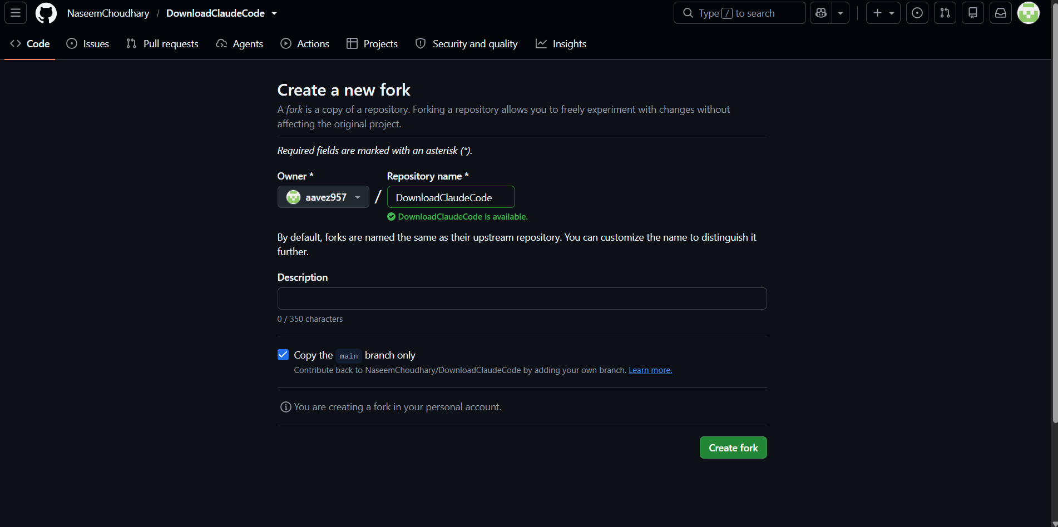
Meaning
Forking creates a personal copy of the upstream repository where a contributor can make changes independently. This is a browser-based step; the URL and result shown here are simulated.
Step 5: Clone the Forked Repository
Student Input
git clone https://github.com/ash3258/hello-contribution-lab.git
cd hello-contribution-lab
Expected Output
Cloning into 'hello-contribution-lab'...
remote: Enumerating objects: 8, done.
remote: Counting objects: 100% (8/8), done.
Receiving objects: 100% (8/8), done.
Resolving deltas: 100% (4/4), done.
Meaning
The remote repository is downloaded to the local computer. Git also creates a local repository and connects the clone to the remote named origin.
Step 6: Check Repository Status and Remote
Student Input
git status
git remote -v
Expected Output
On branch main
Your branch is up to date with 'origin/main'.
nothing to commit, working tree clean
origin https://github.com/ash3258/hello-contribution-lab.git (fetch)
origin https://github.com/ash3258/hello-contribution-lab.git (push)
Meaning
This verifies the current branch, working-tree condition, and the remote repository connected to the local clone.
Step 7: Create a New Contribution Branch
Student Input
git checkout -b docs/update-readme
git branch
Expected Output
Switched to a new branch 'docs/update-readme'
* docs/update-readme
main
Meaning
A separate branch is created for the contribution. The main branch remains unchanged while the documentation work is performed.
Step 8: Inspect the Project Files
Student Input
ls
cat README.md
Expected Output
README.md
LICENSE
src
tests
# Hello Contribution
A small demonstration project for learning Git and GitHub.
Meaning
The existing project files and README are inspected before making a contribution.
Step 9: Make a Small Documentation Change
Student Input
echo "" >> README.md
echo "## Contribution Guide" >> README.md
echo "Contributions are welcome through a Pull Request." >> README.md
cat README.md
Expected Output
# Hello Contribution
A small demonstration project for learning Git and GitHub.
## Contribution Guide
Contributions are welcome through a Pull Request.
Meaning
A small, focused documentation improvement is added to README.md. No source-code functionality is changed.
Step 10: Review the Changes
Student Input
git status
git diff
Expected Output
On branch docs/update-readme
Changes not staged for commit:
modified: README.md
diff --git a/README.md b/README.md
+## Contribution Guide
+Contributions are welcome through a Pull Request.
Meaning
git status shows which files were changed, while git diff displays the exact content added or removed.
Step 11: Stage and Commit the Change
Student Input
git add README.md
git status
git commit -m "docs: improve contribution guide"
git log -1 --oneline
Expected Output
Changes to be committed:
modified: README.md
[docs/update-readme a1b2c3d] docs: improve contribution guide
1 file changed, 2 insertions(+)
a1b2c3d docs: improve contribution guide
Meaning
The modified README is staged and then saved as a Git commit with a meaningful commit message. The commit ID shown is intentionally simulated.
Step 12: Push the Branch to GitHub
Student Input
git push -u origin docs/update-readme
Expected Output
Enumerating objects: 5, done.
Counting objects: 100% (5/5), done.
Writing objects: 100% (5/5), done.
To https://github.com/ash3258/hello-contribution-lab.git
* [new branch] docs/update-readme -> docs/update-readme
branch 'docs/update-readme' set up to track 'origin/docs/update-readme'.
Meaning
The contribution branch is uploaded to the remote GitHub repository. The -u option also sets the upstream tracking branch.
Step 13: Create a Pull Request
Student Input
Open the simulated fork on GitHub:
https://github.com/ash3258/hello-contribution-lab
Select:
Compare & pull request
Base repository: demo-oss-lab/hello-contribution
Base branch: main
Compare branch: ash3258:docs/update-readme
Pull Request title:
Improve README contribution guide
Description:
Updated the README with a basic contribution guide.
Expected Output
Pull Request created successfully.
Simulated PR:
https://github.com/demo-oss-lab/hello-contribution/pull/12
Meaning
The Pull Request proposes the changes from the contribution branch for review and possible merging into the main branch of the upstream project. The Pull Request URL and number are fictional examples.
Step 14: Verify the Contribution
Student Input
git status
git branch -a
Expected Output
On branch docs/update-readme
Your branch is up to date with 'origin/docs/update-readme'.
nothing to commit, working tree clean
* docs/update-readme
main
remotes/origin/docs/update-readme
remotes/origin/main
Meaning
The final status confirms that the local contribution has been committed and the branch has been pushed successfully.

Conclusion
This practical demonstrates the fundamental GitHub contribution cycle: Fork → Clone → Branch → Modify → Stage → Commit → Push → Pull Request. The workflow helps contributors work safely without directly modifying the main branch and provides a structured way for project maintainers to review changes.
Important Git Commands Used
git clone <url> — Copies a remote repository to the local computer.
git status — Shows the current branch and working-tree changes.
git remote -v — Displays configured remote repository URLs.
git checkout -b <branch> — Creates and switches to a new branch.
git add <file> — Stages a file for commit.
git commit -m "message" — Creates a commit with a message.
git push -u origin <branch> — Uploads the branch to the remote repository and sets upstream tracking.
